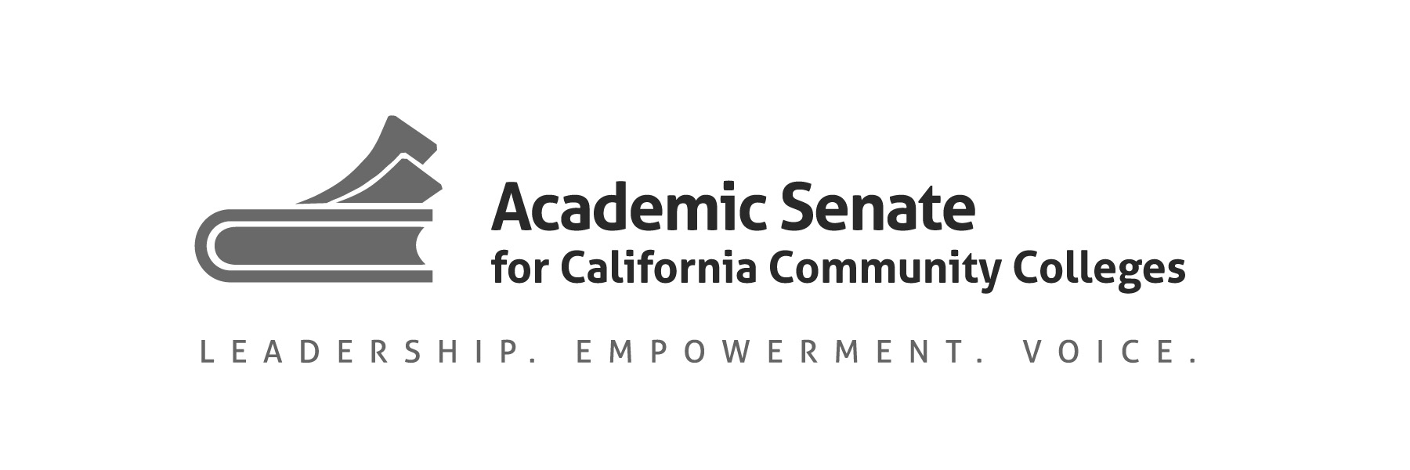

The Exemplary Program Award Application
Each response is limited to 200 words per prompt (including supplemental support or evidence)

Describe the indicators of overall program success (limit 200 words) | Supplemental Instruction (SI) hires SI Leaders, peers that have previously succeeded in difficult courses, to return and support those courses by providing in-class support, mentorship, and study sessions outside of class that are focused on building skills and navigating course challenges. SI tracks the grades of students that attend SI in comparison to their non-attending peers, average GPA improvements, overall participation and usage of program services, and feedback from students, faculty, and staff to measure the program effectiveness. In 2018/2019, our SI Program noted a 0.25 average GPA increase and an average of 12% higher rate of students earning an A, B, or C for students that attended SI when compared to their peers that did not attend any SI sessions.  In this same year, we supported courses in 11 disciplines across four divisions. SI Leaders facilitated 67 - 78 study sessions per week, and served 982 students (5,153 visits) across all supported courses.  SI is a self-reflective program that uses a combination of data, feedback, and assessment to determine areas of growth and improvement. We track attendance to trainings, feedback through observations of SI sessions, and our Canvas course shell assignments.
Supplemental Support or Evidence (optional—included in the 200 word limit):

Describe the identified need for the program and the innovative solution that was implemented (limit 200 words) | The SI Program was created in order to address the need for additional academic support in courses with low success rates and high Failure and Withdraw rates. SI was created as an alternative form of support to traditional tutoring, which often works on a one-to-one model with a tutor that is knowledgeable in the subject.  SI leverages the experience of students that have succeeded in a specific course to assist and guide students currently taking the class. SI leaders attend the class alongside the students, allowing them to foster stronger community and to plan support that will be specific to the content the students are working on. SI sessions are open to all students taking the class to create opportunities to build bonds around studying and for students to use their own strengths to assist and support their peers. SI support is also adaptable to each faculty member’s style and pedagogy, which isn’t always the case with individual tutors.  These differences make SI a valuable addition to the existing academic support available to Skyline College students, especially as we work to meet the demands and needs presented by AB-705.
Supplemental Support or Evidence (optional—included in the 200 word limit):

Explain how the program collaborates with other programs on campus or within the community (limit 200 words) | Providing SI Support across campus requires the Program Services Coordinator (PSC) to work with division deans, faculty, and students in order to positively impact student success. The PSC leads and participates in ongoing discussions on how SI can serve the needs of each division’s students and faculty, especially as we collaborate to identify and implement changes to meet the unique challenges presented by AB-705.  SI works with our Promise Scholars Program (PSP), a program that provides both academic and financial support to first-year, high-need students. We prioritize SI support for sections with high promise scholar enrollment and provide data to track their usage of SI services. The PSP then uses this data to assess which students may need priority assistance or support.  SI has teamed up with our brand-new STEM Center, campus counselors, and the Disabilities Resource Center (DRC) to develop and run trainings that improve the quality and reach of student academic support. In 2019, SI held collaborative trainings with our Counselors on mental health and the Disabilities Resource Center (DRC) on learning styles, accommodations, support/empowerment for our DRC students. These collaborations help us leverage other strengths on campus while also empowering our staff to better serve all students.
Supplemental Support or Evidence (optional—included in the 200 word limit):

Describe how the program supports the principles of your college’s mission statement (limit 200 words) | Core practices of SI are aimed to empower and transform students’ educational experiences and skills, as well as their future academic and professional possibilities. We train our SI Leaders to be lead by example and leverage their own experiences to assist students with skill building, course/content challenges, and mentorship around the community college experience. Our SI Leaders attend trainings on becoming leaders on campus, building group interaction through empowerment, and how to guide students when learning new skills.  This semester we’ve developed a volunteer experience with a local organization that is tasked with helping victims of domestic violence in the Bay Area. We have collaborated across campus to include more training around supporting specific student demographics, including students registered with our DRC and those that have suffered from trauma. Many of our SI leaders have gone on to work with other organizations on campus, such as TRiO, Peer Mentoring, Brothers Achieving Milestones, and Women’s Mentoring and Leadership Academy. Each of these contribute to building leaders on campus that are more involved in their community, which ultimately builds leaders in our program that are engaged and proactive about serving students in our community.
Supplemental Support or Evidence (optional—included in the 200 word limit):

Explain how this program can be a model for other community colleges addressing such issues as costs and replication (limit 200 words) | Our current program costs are over $200,000 per academic year, and the majority of those costs cover wages for SI Leaders. The program is quite scalable to the budget of any institution. If an embedded tutoring or SI program already exists, our SI principles, goals, and action steps can be provided and applied with little to no costs. We focus on student-centered, community-driven support that not only assist students in difficult courses, but also helps create stronger student leadership  As an SI program, we do have similarities to other programs around the nation such as University of Missouri Kansas City’s International SI Program, but our program focuses on provided support that is adaptable to the needs of a community college as opposed to simply using models designed for upper division students and institutions. At the heart, our mentorship model and community building are what make us unique and successful. All SI Leaders are mentored by veteran leaders, faculty, and the PSC of the program. Our SI program supports the mission of our college by making robust connections and leaders that empower and lead their communities.
Supplemental Support or Evidence (optional—included in the 200 word limit):

