RESPIRATORY THERAPY PROGRAM
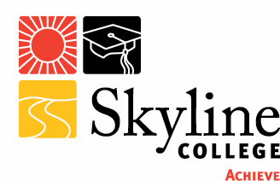
ADVISORY COMMITTEE MEETING
Tuesday, September 18, 2012
5:30 – 6:00pm – Dinner
6:00 – 7:30pm – Meeting
Building 7, 2nd floor, room 7215

AGENDA

Introductions as necessary

Minutes from last meeting

  - Continuing Business
    - Enrollment

    - Budget Update

    - Clinical Site Evaluations

    - Clinical Rotations

    - RT Club Update 2nd Year /1st Year
      - Fundraisers

    - 40 Year Anniversary (1st Graduating Class 1972)

  - New Business
    - Annual CoARC Survey

    - Program Goals

    - College Administrative Changes

  - Announcements/Other
- Lungapalooza – September 22 (San Leandro)
- GBAR Meeting – November 3 (Napa)
- AARC Conference – November 10-13 (New Orleans, LA)

Date for next meeting

