***Skyline College***

***Central Service Technician Program Student Handbook***

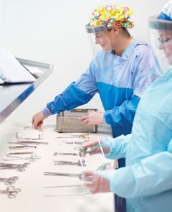

***3300 College Drive***

***San Bruno, CA 94066***

Instructor

**Brian Shea, MHA, CRCST,CHL, CER, CIS**

**Email: sheab@smccd.edu**

**Program Overview**

**SURG 445: Introduction to Central Service Technology**

This course is the starting and foundational study of the Central Service Technology Program. This course is one of three required courses; the student can expect to learn the following concepts in this course:

* Central Service Technology theories and fundamentals using hands-on laboratory skills.
* Decontamination and sterilization processes, procedures, and techniques for various types of clinical equipment and instruments used in various settings (i.e., hospitals, clinics, etc.).
* Basic Human Anatomy and Infection Control.
* Medical supply distribution and supply chain management.
* Quality Assurance methodologies, monitoring, and other associated processes.
* Instrumentation, equipment, and information resource identification/referencing.
* Assembly and maintenance of complex instrumentation, equipment, and information. This includes the use of hazardous materials, chemicals, etc.
* The student must achieve a grade of **C** (**75%**) or better to progress to the next course.

**SURG 448: Clinical Lab Practicum**

This course is the second in a series of courses for the program. The class provides the student with hands-on experience processing surgical instruments and medical supplies in a simulated lab. The student will practice decontaminating, disinfection, inspecting, packaging, and sterilizing selected items. Units will also cover identifying instruments of various surgical specialties such as General Surgery, Urology, Gynecology, Orthopedics, and more. The student must achieve a grade of **C** (**75%**) or better **and pass a competency assessment** to progress to Clinical Practice.

*The student must pass a demonstrative assessment or competency test in this course to be eligible for clinical site placement. A student may not be placed at a clinical site unless they have successfully completed a demonstrative assessment for competency*

**SURG 446: Clinical Practice for the CST**

The final course in the Central Service Technology Program consists of 8 weeks (240 hours) of in-hospital training. The student will be assigned to a central service department in a facility where they will receive supervised experience in sterile processing, supply distribution, and inventory control. To be eligible, the student must show proof of compliance with the mandatory Background Check, Drug Screening, physical assessment, and immunizations. The student must receive a passing Evaluation in to complete the program. See page 14 for more information.

# General Information

**Location:**

SURG 445 and 448 are held in the Surgical Careers Center (Building 7 Room 7205) on the Skyline College campus, 3300 College Drive in San Bruno. The student is advised to consult the syllabus and the Instructor for possible changes to the location.

# Classroom (Room 7205):

Please be aware that other programs, including the Surgical Technology Program, use the classroom. Central Service Departments are kept clean, so the classroom and lab are also expected to be kept clean. There is no eating during lectures and labs for everyone's safety and courtesy of the speaker. Drinks are allowed if kept in sealed containers, such as a travel coffee mug or water bottle. A microwave oven and refrigerator are available for staff and students to use before class or during breaks. If you use these items, please clean up after yourself.

# Hours:

**SURG 445:**

Mondays 6:00 – 10:00 p.m. (two 15 minute breaks)

Tues & Wednesday 6:00 – 9:30 p.m. (two 15 minute breaks)

**SURG 448:**

Mon,Tues, Wednesday 6:00 - 10:00 p.m. (two 15 minute breaks)

**SURG 446 (Clinical Lab/Clinical Site) Monday through Friday**--time varies according to the arrangement between the Skyline Instructor, the hospital CS Manager, and the student. The CS Manager assigns breaks as per policy.

**Surgical Career Center Open Lab hours**

The Surgical Career Center Open Lab hours, are subject to approval by the STM Division Dean based on staff and resource availability. Please consult your Central Service Technology Instructor for additional information.

**Registration For Surg 445 – Introduction to Central Service Technology: All students must complete their registration into the 445 class no later than "one week before class begins".** Failure to complete registration by this date may result in the Instructor withdrawing the student from the program and offering a spot to the next student on the waitlist. Upon completion and passing SURG 445, students must also register for SURG 448 Summer Lab.

**Individual & Package Association Fees (Subject to Change):**

Registration includes $46 per unit plus additional college fees $650

Physical Exam and Immunization Verification (Approx.) $250

HSPA (formally IAHCSMM) Membership Yearly Fee (Approx.) $50 - $60

Textbooks and Misc. Supplies (Approx.) $120 - $143

Castle Branch Package Cost $121

Drug Test (Individual) $35

Background Test & Drug Test (package) $78

Compliance Tracker $43

\**Fees are approximations only. The student may pay fewer fees if treated by their primary healthcare provider or by using the Skyline Health Student Services Center. Professional Association Fees (HSPA) or Castle Branch Fees are controlled by their organization's fee schedule, not Skyline College*.*

**Text Book Materials** — The required textbooks for this course are purchased through the HSPA website using the following link: <https://myhspa.org/education/publications/central-service-technical-training-8.html> (formally known as IAHCSMM). You must purchase the Box Set for the entire program, as all testing materials will come from each book. This Box Set is used for the CRCST test and approved by HSPA.

Book 1:" *Sterile Processing Technical Manual 9th Edition"* by HSPA

Book 2:" *Sterile Processing Technical Manual 9th Edition Workbook"* by HSPAs Editr

**HSPA Membership** — Membership is required for this cohort to help assist you in your course of study and provides you with many resources outside of this course. You should purchase the membership that suits your needs (you are not certified yet, so go with what you can afford). The membership link for HSPA (formally IAHCSMM) is here: <https://www.myhspa.org/membership/member-benefits.html>

# Program Documentation:

Students participating in this program must adhere to documentation requirement deadlines. Failure to adhere to those requirements may result in delayed program entry, clinical site placement, and suspension from the program up to dismissal. Critical documents that must be submitted are "**Student Attestation and Agreement**," *Injury/incident reports* (as applicable), *California Workman's Compensation Forms* (as applicable), and **Clinical site evaluations/time cards**. Please note that background checks, health screenings, etc. *fall under compliance* (Castle Branch), resulting in *automatic* *holds* or *dismissals* for students if not submitted by their defined deadlines.

# *Examples of some forms used in the Central Service Technology program can be found in the APPENDIX of this handbook*

# Criminal Record/Convictions:

Students with certain criminal convictions or criminal records cannot be accepted into the *Central Service Technician* program. The following types of criminal records or convictions will subject the student to immediate ineligibility of remaining in or being admitted to this program (and other Surgical Careers Center programs):

1. Any **Felony** conviction involving **Violence** or **Violent Crime**
2. Any conviction involving **Theft, Larceny, Embezzlement,** or other related crime.
3. Multiple convictions involve **driving under the Influence (DUI)** or driving **intoxicated (DWI)**. *Multiple convictions can be 3 or more and do not have to include other associated crimes*

**\*ANY of the above-listed convictions obtained while in the program is cause for dismissal, whether disclosed or not. Clinical sites are not obligated to take on students if they have a criminal record per their facility policy. Positive Drug testing (even random) also qualifies in this area. \***

# Handbook Amendment/Revision:

This handbook can be revised and amended whenever necessary to enhance and clarify any policy, procedure, regulation, or standard for the *Central Service Technician* Program. Notice of any change will be provided to the student using written, verbal, or digital confirmation (or a combination thereof) citing the date the change takes effect. Handbooks are revised throughout the academic year; refer to the "**Version History**" to ensure you have an updated copy of this handbook.

# Skyline College & Program Policies

**Smoking**:

Skyline College is a Non-Smoking facility (including vaping or using other electronic cigarettes or devices).

# Communication Devices:

Cell phones are to be put on vibrate and put away during class instruction. The student may check cell phones during the break or in an emergency. The school is not responsible for losing or damaging laptops or other devices.

# Change of Student Address:

It is the responsibility of the student to notify Skyline College and the Central Service Program Instructor, in writing, of a change in address or telephone number. If a student moves during clinical rotation, **the program is not obligated to transfer or provide another clinical site to the student if they move or change their address.**

# Certification:

There are several different types of nationally recognized certifications within the U.S. Two organizations: HSPA (previously called IAHCSMM) and CBSPD (previously called NICHSPDP). Each certification differs from the others, as are the organizations and content materials (they have similar equivalencies). Skyline Community College primarily uses **HSPA materials** but may use CBSPD materials anytime. Course instructors will provide you with required material reference information if CBSPD materials are used. Be aware that the Instructor may choose to use a combination of HSPA, and CBSPD materials or stick to one type of material. Consult your course syllabus and Instructor for additional details and information.

*CRCSTs* are certified by *HSPA* (previously called IAHCSMM) in collaboration with Skyline College. Applications for the exam may be distributed to the class at the end of the program. There is an additional cost for the certification exam (payable to the appropriate professional organization), and the Instructor of Record must complete paperwork for the class**. To sit for the HSPA (IAHCSMM) exam, the student must complete 400 hours of Clinical experience.** The 3 Semesters of the Central Service Technical Program will allow the student complete **400 hours** in the following areas:

* **96** hours of **Sterilization & Disinfection** are obtained in **SURG 445 & 446** courses (HSPA CRCST Application Sections 3).
* **24** hours of **Storage & Distribution** are obtained in **SURG 445 & 446** courses (HSPA CRCST Application Section 4).
* **24** hours of **Quality Assurance Processes** are obtained in **SURG 445 & 446** courses (HSPA CRCST Application Section 5).
* **16** hours of **equipment** are obtained in **SURG 445 & 446** courses (HSPA CRCST Application Section 6).
* **120** hours of **Decontamination** are obtained during **SURG 448** during the clinical externship (HSPA CRCST Application Sections 1).
* **120** hours of **Preparing & Packaging Instruments** are obtained during **SURG 448** during the clinical externship (HSPA CRCST Application Sections 2).

*\*The student is responsible for all hours and documentation submissions (including HSPA Applications), maintenance, and reporting. Reported clinical hours must be within* **5 years** *of experience* *per HSPA guidelines. Skyline is not responsible for student records pertaining to HSPA certification\**

# Attendance:

It is the responsibility of the student to notify their Instructor as far in advance as possible of any impending tardy or absence. SPD and OR Managers see frequent tardiness and absences as unprofessional and can cost a C.S. Technician his/her job. Regular attendance in class and clinical is an obligation assumed by every student at the time of registration. As this is an intensive training program, **any** absence may put the student's chance of success at risk. College policy states**: "When repeated absences place the probability of the student's success in doubt, the professor may drop such a student from the course." It is the prerogative of the professor to determine when absences are excessive."**

# Absences:

Absence means non-attendance for **ANY** reason.

If a student has 2 absences, the student must meet with the Instructor to discuss the reason for the absences and offer assistance to prevent further absences. If the student has 3 absences, the Instructor will send an early alert to the student, his/her counselor (if applicable), and the Director of Allied Health. Failure to follow the above policy can result in the student's grade being negatively impacted or the student being dropped from the class.

# Tardiness/Leave Early:

Every class day, students will be expected to sign in by 6:10 p.m. Signing in after 6:10 p.m. will be considered tardy. If the student leaves before the end of the class, the student will be regarded as leaving early. Three tardies and/or leave early=1 absence. If the student is 30 minutes late, it will be counted as an absence.

# Notification Procedure:

If, for any reason, the student finds that s/he will be late or absent from a clinical site, said student is expected to:

1. Always keep the phone numbers of the Instructors and Clinical sites with him/her.
2. Call the Instructors and the Clinical site before the start of the Clinical day.
3. Whenever possible, give prior notice in writing.
4. "**Failure to Report**" (**FTR**) means a student failed to call/notify or "**Report**" to their assigned duty station/clinical site when expected to by a supervisor.
5. "**Failure to Appear**" (**FTA**) means a student was a "**No Show**" at the site or disappeared from the clinical site without notifying anyone of their departure or the departure was unauthorized.

**\*Any student who fails to notify their clinical site supervisor and the course Instructor of their absence is subject to receiving a failing grade or "No Pass" for non-compliance. "No Call, No Show" is an automatic job termination in the healthcare field and has the same effect in this program. FTR/FTA or any combination thereof as mentioned above is cause for disciplinary action up to dismissal. \***

# 

# Daycare:

The College Children's Center offers daycare to low-income families from 7:30 a.m. to 5:00 p.m. The Center is located behind the Loma Chica School, on the north side of the college campus. Children must be 18 months or older, and the parent must show proof of financial need. Places fill up quickly, so call as soon as possible. For more information, call 650-359-8637.

# Educational Access Center (EAC)

In coordination with the EAC, reasonable accommodation shall be provided to any student deemed qualified by the EAC office. This includes learning disabilities as well as physical disabilities. If you have special needs, please see the Instructor on or before the first day of class to submit your accommodation letter and to discuss your needs. For more information, contact the EAC office at 650-738-4280.

**\*Students with an Academic Accommodation Plan (AAP) must have a current "Accommodation Authorization" for the semester they are enrolled in to be valid. "Accommodation Authorization" is not retroactive and is enforced according to Skyline Community College policies, procedures, and applicable Federal and State laws. Early "Accommodation Authorization" submissions can help reduce accommodation issues within the program\***

**\*The student must inform their clinical instructor/Coordinator of ANY reasonable accommodation as prescribed by Skyline EAC and Accommodation Authorization. Failure to do so may create clinical site complications or site placement delay\***

# Probation/Dismissal Policy:

Violation of policies will result in verbal counseling. A report of the counseling will be placed in the student's records. If a second counseling is required, a contract of expected behavior or performance will be drawn up and signed by the student (and may include a "Student Success Plan" or another academic documentation plan). A copy will be placed in the student's records, and a copy will be given to the student. The student shall be monitored and counseled until the performance criteria written in the contract have been met. Failure to meet the documented behavior or performance criteria may lead to dismissal. The student will be informed in person and writing of the reasons for his/her dismissal.

If the student demonstrates the behavior described in points numbered 4 through 7 in the "**Professional Conduct: Be Advised**" section, s/he will meet with the Instructors and receive a written dismissal notice. The student will then meet with the Dean of Science, Technology, and Math to confirm the dismissal.

# Minimum Satisfactory Academic Progress (Minimum Grade):

Students who are enrolled in this program must maintain a minimum grade of 70% or its equivalency letter grade (i.e., C-) to remain eligible to sit for the CRCST exam and/or other nationally recognized Central Service exams. Failing to maintain a minimum of 70% or its equivalency letter grade (i.e., C-), can cause the student to be ineligible for a provisional or temporary certification application. Even if a student can successfully complete their clinical hours, national certifying exams mandate a minimum threshold of 70% or letter grade equivalent to obtain certification (for further information, please consult appropriate national certifying body standards and criteria). Also note that any student who has less than 75% or letter grade equivalency (C, C-, D+, D, etc.) may have their "**Academic Program Standing**" status changed.

# Academic Program Standing:

A student can have an academic "standing" as outlined in the Skyline College Catalog if the student meets certain academic conditions. Each "standing" identifies specific actions, events, and consequences of each "standing." A student does not have to satisfy all events, actions, or events to be awarded a certain type of "standing." Program Academic standing does not overrule Skyline College Academic standings but will specify if a student has demonstrated either positive or negative actions within their respective program.

"**Good Standing**" – The student has no academic, discipline, or other adverse events associated with their program file or has any negative administrative actions filed (including pending administrative actions). The student has not repeated a course throughout their program unless it was authorized due to unforeseen or uncontrollable circumstances or through no fault of their own (i.e., medical leave, personal leave of absence, investigation outcome, etc.). The student maintains a minimum passing grade of 75% or letter grade equivalency (i.e., C).

"**General Standing**" – The student has minor or minimal academic, discipline, or other adverse events associated with their program file or negative administrative actions filed (including pending administrative actions). The student has repeated a course throughout their program due to behavioral or negative administrative issues. The student maintains a minimum passing grade of 71% or letter grade equivalency (i.e., C-).

"**Probationary Standing**" – The student has several major academic, discipline, or other adverse events associated with their program file or negative administrative actions filed (including pending administrative actions). The student has repeated one or more courses throughout their program due to academic, behavioral or negative administrative issues. The student maintains a minimum passing grade of 70% or letter grade equivalency (i.e., C-). Student Success Plans or other administrative counseling plans/outlines need to be met to be removed from this area.

"**Disqualification**" – The student has several major academic, discipline, or other adverse events associated with their program file or has negative administrative actions filed (including pending administrative actions). The student has repeated multiple courses throughout their program due to academic, behavioral, or negative administrative issues. The student maintains a grade below 70% or letter grade equivalency (i.e., D, F, No Pass, etc.). The student has compliance or competency issues, has falsified documentation within the program (including program application period), or has become ineligible for program continuation. Student Success Plans or other administrative counseling plans/outlines must be met to be reinstated into an appropriate program course or pathway. Students cannot continue the program until this status is removed.

"**Pre-Dismissal Level I**" – The student has several major academic, discipline, or other major adverse events associated with their program file or has major negative administrative actions filed (including pending administrative actions). The student has repeated multiple courses throughout their program due to academic, behavioral, or negative administrative issues. The student maintains a grade below 70% or letter grade equivalency (i.e., D, F, No Pass, etc.). The student has compliance or competency issues, the student has falsified documentation within the program (including the program application period) or becomes ineligible for program continuation. Student Success Plans or other administrative counseling plans/outlines must be met to be reinstated into an appropriate program course or pathway. Students are given this preliminary notice before permanent program dismissal.

"**Pre-Dismissal Level II**" – The student has several major academic, discipline, or other major adverse events associated with their program file or has major negative administrative actions filed (including pending administrative actions). The student has repeated multiple courses throughout their program due to academic, behavioral, or negative administrative issues. The student maintains a grade below 70% or letter grade equivalency (i.e., D, F, No Pass, etc.). The student has compliance or competency issues, has falsified documentation within the program (including the program application period), or has become ineligible for program continuation. Student Success Plans or other administrative counseling plans/outlines must be met to be reinstated into an appropriate program course or pathway. Students are given this Final notice before permanent program dismissal.

"**Permanent Discharge**" – A student is permanently dismissed from the program due to exceeding the required number of course retakes (per **California Education Code**), irreconcilable behavior issues ("**Professional Conduct: Be Advised section**"), severe criminal acts conducted at clinical sites, or any combination of actions or behaviors not listed within the handbook but are applicable to their program. *Competency* and *compliance* issues are the mechanism for "**Permanent Discharge**" and will be listed on the student discharge paperwork along with noted violations of policy, procedures, etc. This standing is administered after all corrective and disciplinary measures have been attempted or if, for personal/patient safety reasons, cannot be executed promptly (i.e., an active threat poses an immediate issue to a fellow student, staff member, clinician, patient or other individual). Pre-Dismissal Level requirements do not apply if the threat or action of a threat is severe enough to cause harm to the other party or parties involved.

# Grievance Procedure:

Should a student disagree with any policy or decision regarding his/her status in the program, he/she may initiate the following procedure for filing a grievance:

**Step 1:** The grievance shall be presented in writing to the Instructor within thirty (30) calendar days after the date on which it arises. The Instructor shall reply in writing within seven (7) calendar days after receipt of the grievance. **Step 2:** If the grievance is not resolved at Step 1, the student must then submit the written grievance to the Dean of the Science, Technology, and Math Department within seven (7) calendar days after the presentation of the Instructor's reply. The college's grievance procedure then handles the dispute. (See the College Student Handbook).

# Health Policies

**Leave of Absence:**

For an absence of greater than a week, the student must request a Leave-of-Absence in writing from the Program Manager. Personal Leaves are granted on a case-by-case basis. For Medical Leaves-of-Absence, a letter from the student's physician must accompany the request. The letter must describe the malady and the estimated length of time the student is unable to attend school. Prior to his/her return from a Medical Leave-of-Absence, the student must submit a statement from a physician verifying that the student still meets the physical requirements for training in this program. Leaves are granted if and only if the

* 1. Student's academic standing and clinical performance are acceptable and
  2. Leave will not place the student's standing at risk and
  3. Malady does not pose a long-term risk to the student working in the O.R. If the request is made during SURG 445 the Instructor may exercise the policy for Excessive Absences (See "Attendance") and withdraw the student. If the request is made during SURG 446, the Instructor may require the student to make up the time with Extended Training at the Clinical Site or at another site at a later date. The student will receive an Incomplete on his or her records. Completion of Extended Training is not to exceed one year past the graduation date of the class. The student is responsible for initiating negotiations with the Clinical Site for the Extended Training. However, the Instructor must receive in writing an agreement from the site verifying their permission to allow the student to extend his/her training. Upon completion of the Extended Training, the Manager will submit a Change-of-Grade request with Admissions and Records to remove the Incomplete. The graduate will then receive his/her Certificate of Completion.

# Appointments:

Doctor, dental or other appointments should be made before or after class or clinical hours. If, under extenuating circumstances, the student must attend an appointment during class hours, the student is expected to notify the instructor in writing before making the appointment.

**NOTE**: The student will be training in a healthcare facility. Therefore, if the student presents with contagious symptoms, they are strongly advised to stay home and rest. Examples of contagious symptoms include:

* Fever greater than 100° F;
* Excessive cold symptoms;
* Skin eruptions or recent and/or draining wounds on hands or arms.

If the student is experiencing pain for which over-the-counter medications are ineffective, the student must see a physician and report to the Instructor. The student may NOT train at the Clinical site if he or she must take a controlled substance for pain relief.

*If a student becomes positive for Covid-19, they must inform their Instructor and clinical site of exposure so appropriate measures can be taken to safeguard clinical staff, students, etc. Time taken off for Covid-19 must meet Skyline College policies, especially regarding attendance. *

# Worker's Compensation:

The Central Service Technician student is considered "a person in work-experience education or occupational training class" and, according to California State law (#3368 of the Labor Code), is considered an employee of the San Mateo Community College District. If the student becomes ill or injured while performing their duties, s/he is entitled to Worker's Compensation benefits. Claim forms are available in the Health Office or from the Program Manager. Please be advised that the student cannot/should not go over the allotted **240** clinical hours, as the student runs the risk of negating their Worker's Compensation benefits.

# Hepatitis B Vaccination:

Before entering SURG 446 Clinical Experience, every student must show proof of immunity to Hepatitis B. The immunization series consists of one shot followed in one month by the second shot and the third shot six months later. Some Clinical sites will allow students to commence training after 2 shots, pending the 3rd, but others will not. The clinical Coordinator who works with the students regarding Immunizations and Background Checks will have that information. The student must then obtain a titer to determine if s/he is "seropositive" (immune). If the student fails to seroconvert from negative to positive after receiving the vaccine series, s/he must receive a "booster" and have another titer drawn. If, after the booster, s/he is still not considered immune, the student shall receive counseling from the clinical Instructor or the Program Director about the risks of working in a C.S. department. If the student accepts these risks, s/he will be asked to complete a waiver form. A copy shall be placed in the student's record and given to the student.

# Covid-19 Vaccination:

Before entering SURG 446 Clinical Experience, every student must either show proof of Covid-19 vaccination or declination of such vaccination. The vaccination requirement varies per clinical site, as does the combination of each injection. Some Clinical sites will have specific combinations they acknowledge per CDC guidelines. Clinical sites are not required to accept students who do not have Covid-19 vaccinations or decline the vaccination. Students who are not or refuse vaccination must provide paperwork on file indicating their reason for doing so (i.e., religious grounds, medical contraindications, etc.). Sites can prohibit students who decline the shots to safeguard their staff and patients. Students are advised to consider the choice of rejecting or refusing to take the Covid-19 vaccine. The Central Service Technology does NOT require students to take the Covid-19 vaccine nor mandates it (the option is up to the student). Clinical site placement may not be possible or restricted if the student does not have the Covid-19 vaccination.

# Latex Allergy:

Be advised that many products used in Central Services contain latex and that working in this environment places a person sensitive to latex at significant risk. Suppose it is found that a student is sensitive to products containing latex. In that case, the student must be evaluated by an allergist familiar with the Centers for Disease Control protocols. The student shall be counseled by the Instructors and provided with a list of latex products and alternatives. The Central Service Manager of the student's Clinical site shall be notified, and accommodations shall be made to prevent the student's exposure to these products. If accommodations cannot be reasonably made, upon the allergist's recommendation, the student shall be dismissed from the program for his/her protection. Documentation of the allergy is the student's and Instructor's responsibility. Copies shall be placed in the student's record and given to the student.

# Policy & Procedure for Students Injured at the College/Clinical Site:

If a student becomes ill or is injured while in class, they should:

1. Report the incident to the Instructor of the Central Service Technology course immediately. Serious injuries may prevent you from continuing the course or leaving the facility. The Instructor will do their best to notify appropriate parties to assist you (i.e., relatives, etc.). *Ensure emergency contact information is up to date.*
2. Obtain treatment at the Health Center *if the* *injury occurs on campus*. Should the injury on campus occur after the Health Center *closes or outside of the Health Center business hours*, Emergency Services (i.e., 911) may be called to obtain treatment or transport you to a healthcare facility. **If an injury occurs at the clinical site, get treatment at the clinical site, and ensure all injury and incident reports are completed before you leave the facility**. **You must file a Skyline Incident Injury Report with the following information:** a printed legible name of the person treating you and their title, what treatment they provided you, date of treatment, location of treatment, and time of treatment. If it is not legible, you may have issues with your claim.
3. File a California Workman's Compensation packet with the Instructor within 24 hours of the incident to ensure you are covered for other issues related to your injury. A copy will be provided to you and Skyline Human Resources for processing.
4. Suppose you receive a medical bill from the facility or institution. In that case, you are required to bring that bill to Skyline Human Resources for processing, as you may not be liable for payment (if the injury is proven to have occurred at the site or campus during your clinical time). The clinical facility is mandated to provide you with some form of treatment (either a band-aid or other care as they deem appropriate).
5. Your course instructor or designated Skyline College (i.e., Human Resource person, Nurse, Clinical Coordinator, etc.) representative will follow up with you with any additional paperwork, counseling, education, etc., regarding your injury.

**Policy & Procedure for Students Injured or Exposed to Body Substances at Clinical Rotation Site (additional information):**

Definitions: "Body Substances" include tissue and/or body fluids, especially blood and fluids contaminated with blood. "Exposure" means the substance contacted bare or broken skin and/or mucous membranes. The student should

* Immediately report the accident, injury, needle stick, splash, or other exposure to body substances. Report to the Instructor of the Central Service Technologist program and the CS Manager or Supervisor.
* Follow the hospital's protocol for employees regarding accidents or body substance exposures.
  1. Obtain treatment.
  2. Complete all mandatory hospital forms (except Worker's Comp, which is filled out with the Instructor later)
  3. Keep copies for your records
  4. Complete the Program's Incident Report
  5. Complete Skyline's Workers' Compensation form
  6. Submit all forms to the Program Instructor

# Central Service Technician Clinical Experience

**Clinical Skills:**

During **SURG 448,** the student is expected to acquire some clinical skills at the beginner level. The majority of Surg 448 is Instrumentation Identification. Once a skill has been demonstrated, the student is expected to practice independently in-class labs to prepare for the Clinical Skills Check-off. The student MUST pass the Skills Check-off (Demonstrated by Instrumentation Exams). Should the Instructor feel that the student needs remedial work before Clinical experience, s/he will notify the Central Service Technology program lead/coordinator or appropriate administrator of this need.

# Before starting the Clinical experience, every student must submit the following:

# An acceptable Social Security number referenced Background Check

# A Negative Drug Screen

# An Acceptable Physical Assessment

# Proof of immunity to Hepatitis B, Measles, Mumps, Rubella, Varicella.

# Proof of vaccination against Influenza, Diphtheria, Tetanus, and Pertussis.

# Proof of a negative Tuberculosis test

# Proof of Covid-19 Vaccination or declination letter with reason.

# Flu shot (current season) or declination letter with reason.

# These documents must be on file with the Central Service Program instructor/coordinator no later than the end of the Spring Semester. Failure to comply will result in the student being barred from registering for SURG 448 in the summer.

# *If you provide a declination letter for any of the above-requested materials, a clinical site has the RIGHT to reject your request for placement. Clinical sites may also request additional paperwork or other types of immunizations/vaccinations that may not be listed*

**Clinical Experience (SURG 446):**

The Instructor assigns clinical sites in conjunction with the Clinical Coordinator. There are no guarantees of site location, shift, or availability. The student must be prepared to have adequate transportation. Most Clinical sites are Monday through Friday Day Shift (7 or 8 a.m. to 3:30 or 4:30 p.m.). Clinicals on the weekends and evening shifts are rare and require approval from the course instructor, program coordinator, appropriate program administrator, and clinical site. The student is expected to be available for at least 6 hours per assigned day or other predetermined time schedules as authorized by the clinical site and program instructor/coordinator.

# Suppose the student is unable to commit to at least a 30-hour training week or predetermined time schedule by a clinical site. In that case, the student must inform the instructor at the start of the program AND before applying for a clinical site. The student should be aware that completing the Clinical experience is mandatory to complete the program and be eligible for a job.

To pass the Central Service Technician course, the student MUST satisfactorily meet the Clinical Objectives, course work, and other assessments as necessary. Clinical grading is based on a Pass/Fail credit; there is no letter grade.

# Student Clinical Assignments:

The student must be assigned to appropriate learning opportunities at a Clinical site. A Preceptor must always be immediately available to assist the student. Sometimes, a Hospital may be short of C.S. staff and ask the student to "fill in" or "cover" an area alone. A student **may not** be assigned in place of a trained employee. This policy is in place to protect the patient from harm and the student and the hospital from legal liability. **A student MUST have a preceptor assigned to them and cannot continue a shift or assignment unless they are available to them in their area (students cannot be by themselves).** The Central Service Technology program only offers 1 clinical site placement per student. A student will not be offered a 2nd site placement unless a situation occurs outside the student or program's control.

*Any student who refuses to accept a clinical site placement may be given a failing or "No Pass" grade for that course and site placement. It is at the discretion of the instructor of record to decide the final grade determination per California Education Code*

**Be advised if, for any reason, a student returns to the program after an extended absence (i.e., dismissal from a clinical site, Leave of Absence, etc.) the student will be required to perform a demonstrative assessment and/or additional assessments to indicate they are competent in returning to a clinical site. *Students who do not schedule or pass their demonstrative and/or additional assessments will not be eligible to return to clinical sites or be eligible for clinical site placement.\***

**Repeating Coursework and "Returning Students"**

If the student returns to the program after an absence, the student may be required to repeat some of the immunizations or tests and complete a new Background Check and Drug Screen. The College must comply with the requirements of the hospitals. In addition, the student must demonstrate minimal competency in the required skills (see above *notation). **Repeating coursework does not guarantee placement in ANY cohort or clinical site.** Returning students are placed when clinical and classroom slots become available for them and after completing all requirements as outlined in the program handbook. Returning students **do not receive priority or preferential placement** within this program.

**Returning students**

A student who is unsuccessful due to academic or nonacademic reasons and wishes to return to the program will be considered for re-entry based on the following merits:

1. The student's academic standing, attendance, clinical skills, attitude, and behaviors during his or her involvement with the program.
2. Clear reasoning for the student leaving the program including academic, financial, occupational related, personal, medical, or other indicated reason/issue.
3. Resolution or the potential for resolution for the student to be considered for re-admission. Resources to help develop this plan may include but are not limited to academic support, financial aid, academic or personal counseling, or consultation with the Education Access Center (as it is applied case by case basis), and any other associated Skyline College agency.
4. The faculty and clinical instructors' judgment on the student's potential to successfully complete the classroom and clinical phase of the training.
5. No restrictions, holds, or sanctions that can affect their academic or program standing. If such restrictions, holds, or sanctions exist, a student success plan or other administrative document that shows those issues are identified and resolved through some improvement process.

# Professional Conduct:

A student in this program is under constant observation by healthcare professionals, patients, and visitors at the College and the Clinical site. Ten percent (10%) of the student's grade is based on his/her professional conduct, as defined below.

Failure to comply with the following rules of behavior may be grounds for dismissal from the program.

The student is expected to:

* Abide by the policies of the program as defined in this handbook.
* Attend all classes and clinical days.
* Be prompt to all learning sites, styles, and clinical.
* Arrive at each learning site prepared to learn, which means the assigned reading is completed, the student has materials for taking notes, and the student is dressed appropriately.
* Submit assigned coursework or required documentation on its due date.
* Treat all persons and property with respect.
* Observe the privacy and confidentiality of all persons.
* Participate in class discussions and in team projects.
* Attend In-services and Morning Reports at the Clinical Site if appropriate.

**Be Advised**: All hospitals have policies regarding the behavior of the employee. Hospitals may fire an employee who exhibits any of the behaviors listed below. In this program, a student shall be subject to disciplinary action, including dismissal for these same behaviors:

1. Frequent absences.
2. Frequent tardiness.
3. A student fails to submit documentation promptly and on time or falsifies documentation.
4. Abusive, lewd, foul, or threatening behavior to patients, other students, faculty, or clinical staff members
5. A student is observed to be under the influence of drugs or alcohol.
6. A student is observed cheating or stealing.
7. A student is observed deliberately damaging College or Hospital property. While the College Clinical Coordinator will be in weekly contact with the student and/or the Manager of the site, it is not only appropriate but advisable that the Clinical site Manager/Supervisor call the College Clinical Coordinator to discuss any unsuitable behavior exhibited by the student. Removing a student from the site, depending upon the reason for dismissal, could result in termination from the Central Service Technology program.

# Dress Code:

Students are expected to appear neat and professional in class and at the Clinical sites. Each Clinical site could be a future employment site or a source for a letter of reference. Students are advised to dress accordingly.

* In the Central Service Department, the student shall wear official Central Service attire (scrub suit) according to the institution's policy. **Do not wear street clothing or personal scrubs uniforms while working in the clinical site Central Department.**
* The student will be provided a name tag by the clinical site. The name tag is to be worn during Clinical. Lost tags must be replaced as soon as possible.
* For the student's safety, jewelry and valuables must be left at home and cannot be worn at the clinical site during clinical hours.
* Contact lenses may be worn. Regular glasses must be worn for procedures where hazardous fumes may affect contact lenses.
* **No nail polish or artificial nails shall be worn**.
* Walking shoes shall be worn in the Central Service Department. **Open-toe and sling-back sandals are considered unsafe and cannot be worn.**
* Scrub uniforms of matching color (Gray variation such as Pewter) may be purchased by the student to be worn during SURG 448 and SURG 446 (while in the lab or when arriving at the clinical site).

# Program/Class Evaluation:

The Central Service Technology Program students often give excellent suggestions on how to improve the course. Students are encouraged to offer candid and constructive criticism. A Program Evaluation may be given to the students during the last class when the final exam is reviewed. Another may be mailed, provided in person, or sent electronically to the student.

# Graduation:

Upon completing the program, the graduate is strongly encouraged to attend the Course Appreciation Ceremony. At the Ceremony, the student will receive a Certificate of Completion. A semi-formal ceremony may include a presentation of certificates, pins, medals, and a lab coat. The student is encouraged to share this Graduation with their family and friends.

The "Donning of the Lab Coat" and "Pinning" Ceremony is an optional ceremony where family members can participate in the graduate donning their professional attire as a health care professional.

*Please note that the certificate presented is not the *Official* *Certificate of Achievement*. The student must ensure they receive the *Official* *Certificate of Achievement* from Skyline Community College as outlined in the Skyline Community College catalog policies and procedures*

# Version History

1/5/16

Reviewed and revised on 8/4/16 Reviewed and revised on 6/6/16 Reviewed and revised on 10/10/2016 Reviewed and revised on 5/26/19 L.B. Reviewed and revised on 11/13/19 CC Reviewed and revised on 12/17/19 R.H.

Reviewed and revised on 11/11/22 A.E.

Reviewed and revised on 12/22/22 R.L.

Reviewed and revised on 4/7/23 R.L.

Appendix

Authorized Forms

Sample EAC "Accommodation Authorization" Form

*This form is for students who require additional accommodations only*

**SAMPLE**

**EXHIBIT**

*This form MUST be updated each semester you are in the program to be valid per Skyline Community College Standard Operating Procedure. *

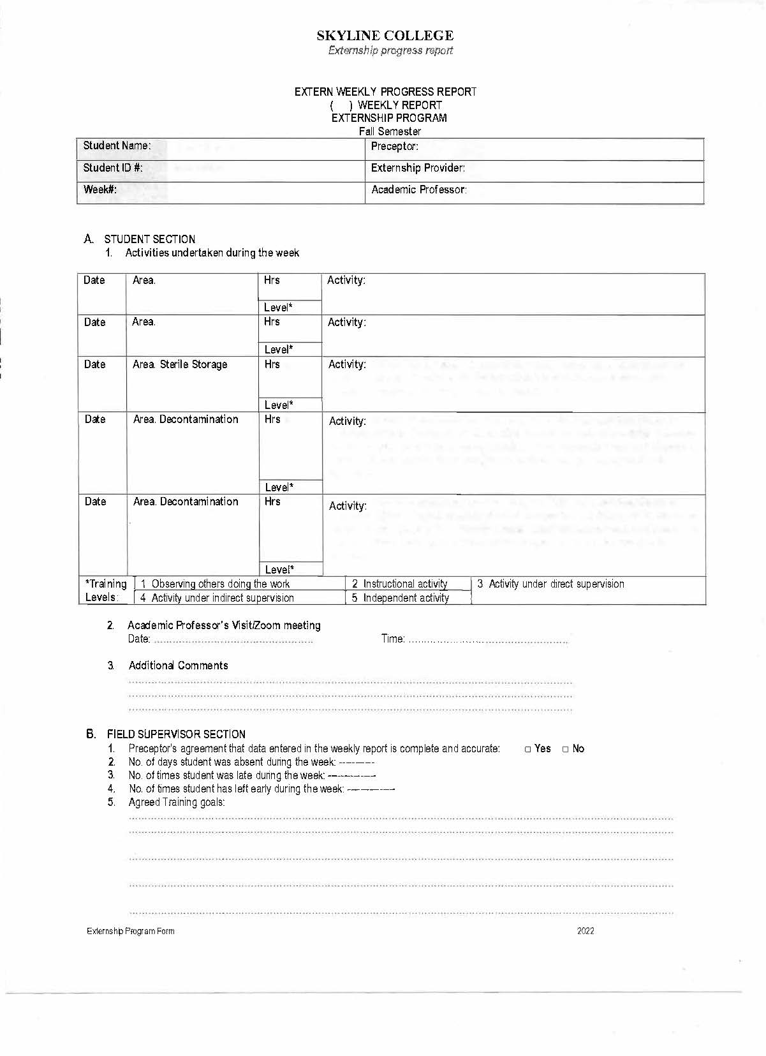

**Clinical Evaluation Forms**

**Grading Rubric Sample**

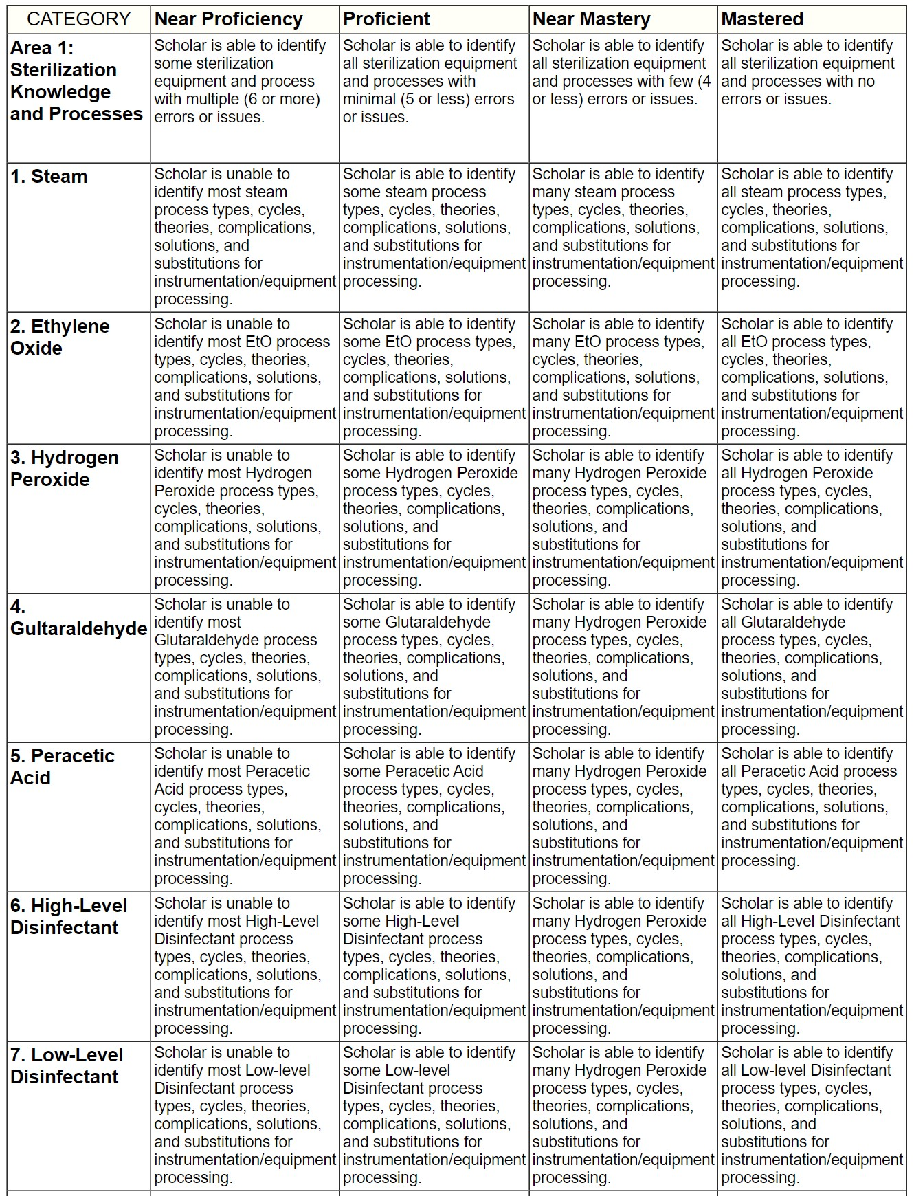



Student Attestation and Agreement

I have received the student handbook in either paper or digital format, read the policies and procedures, and accept that I am responsible for all the information in the **Skyline College Central Service Technician Program Student Handbook**. I understand that if I *disagree* with the contents of this handbook, I may **voluntarily withdraw**from the program or be **involuntarily dismissed** for **non-compliance.**

\***There are no guarantees of re-entry into the program or a cohort if I withdraw or am dismissed from the program or any cohort**\*.

Student Printed Name: ___________________________

Student Signature: _______________________________

Date: _________________

**Instructor Disclaimer:**

The student has been advised of the program's requirements, expectations, policies, procedures, and other standards outlined in the Skyline Community College current year catalog, Clinical site rules, and other related regulations on their role as a *Central Service Technician Student*. Information was disseminated in a presentation (using various methods) during orientation, in person, via Zoom, verbally, in writing, or through a public mechanism they could access.